ANGULAR FINAL PROJECT

TITLE : ELECTRONICS STORE (NAMED as VOLT & VISION)

SCREEN SHOTS OF MY PROJECT’S OUTPUT :

1.HOME PAGE

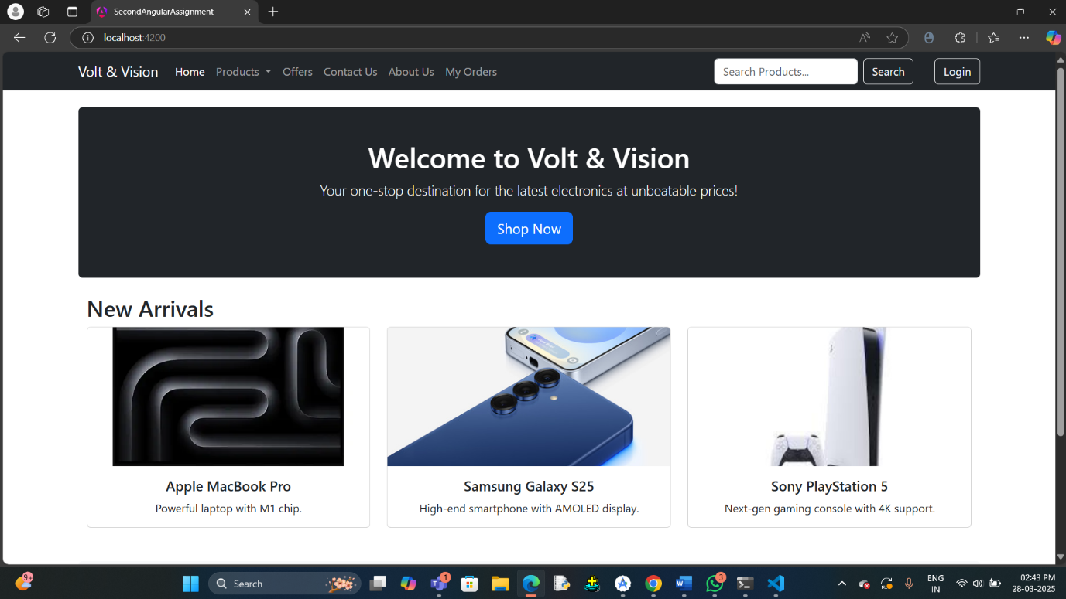

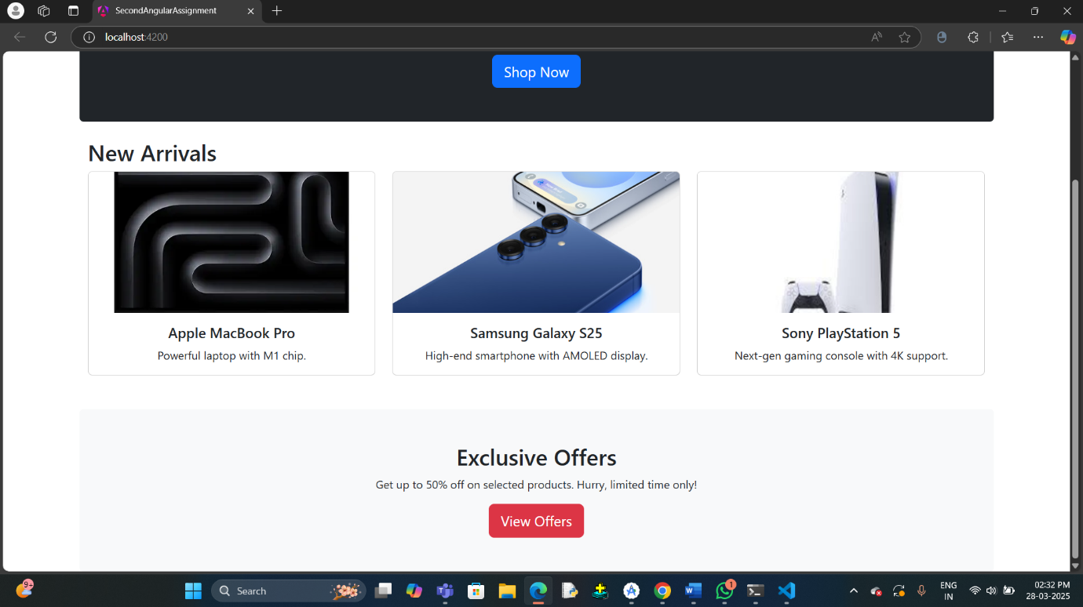

2. NAVIGATION BAR WITH DROP DOWN MENU

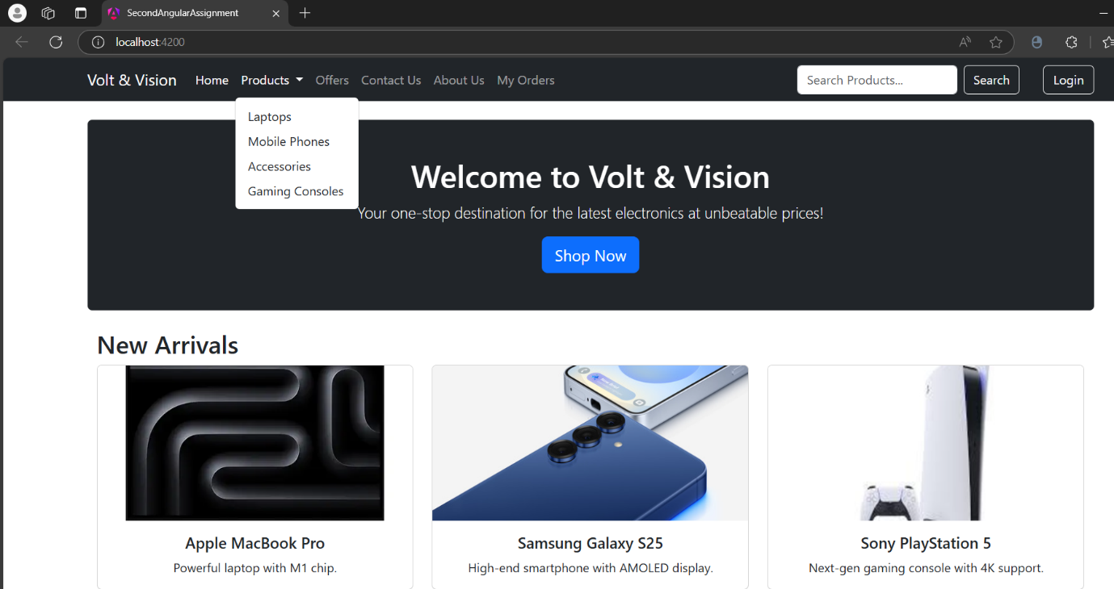

3.OFFERS PAGE

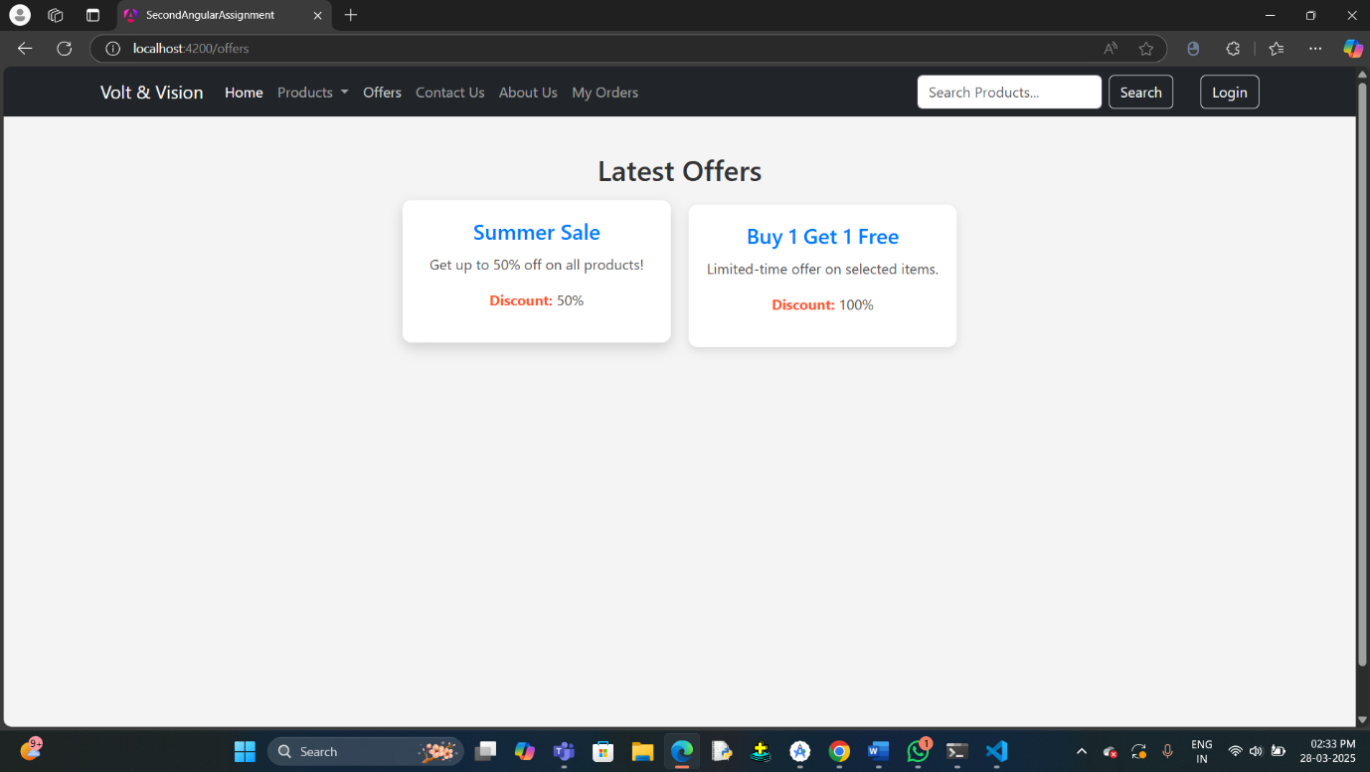

4.LAPTOPS PAGE

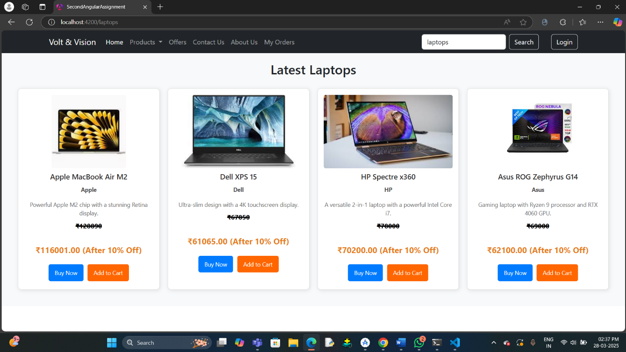

5.MOBILE PHONES PAGE

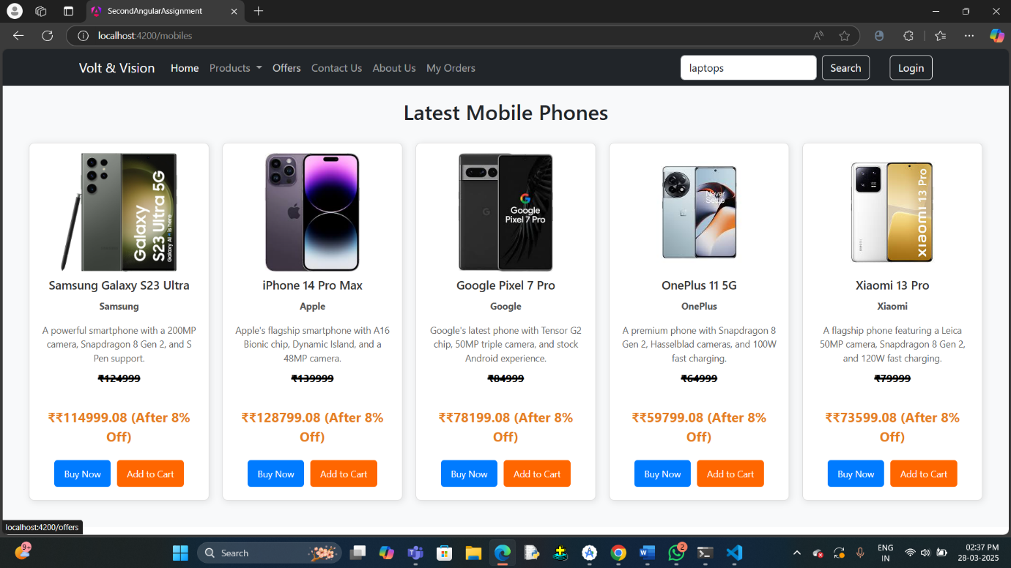

6.ACCESSORIES PAGE

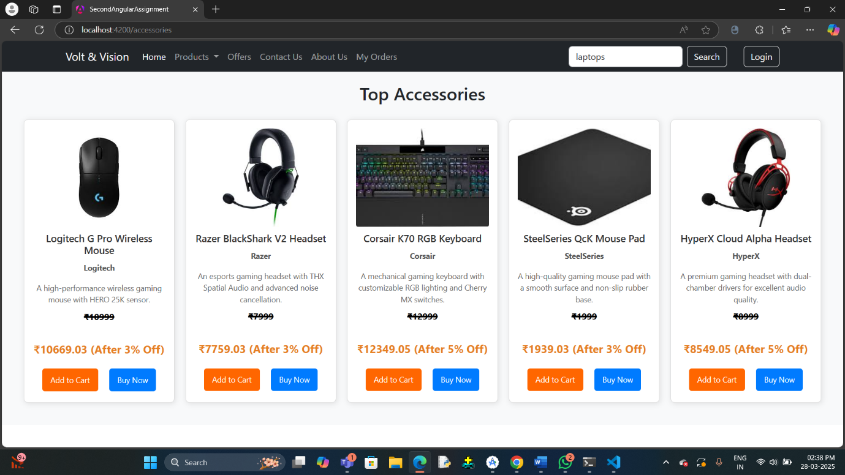

7.GAMING CONSOLE PAGE

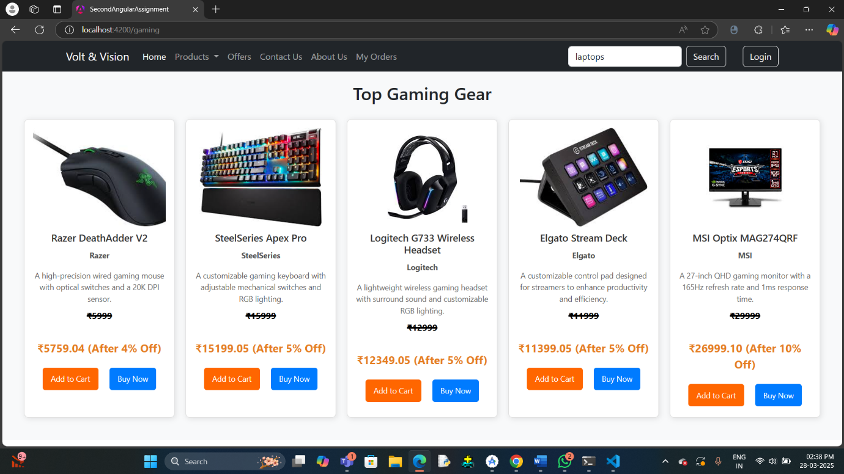

8.CONTACT US PAGE

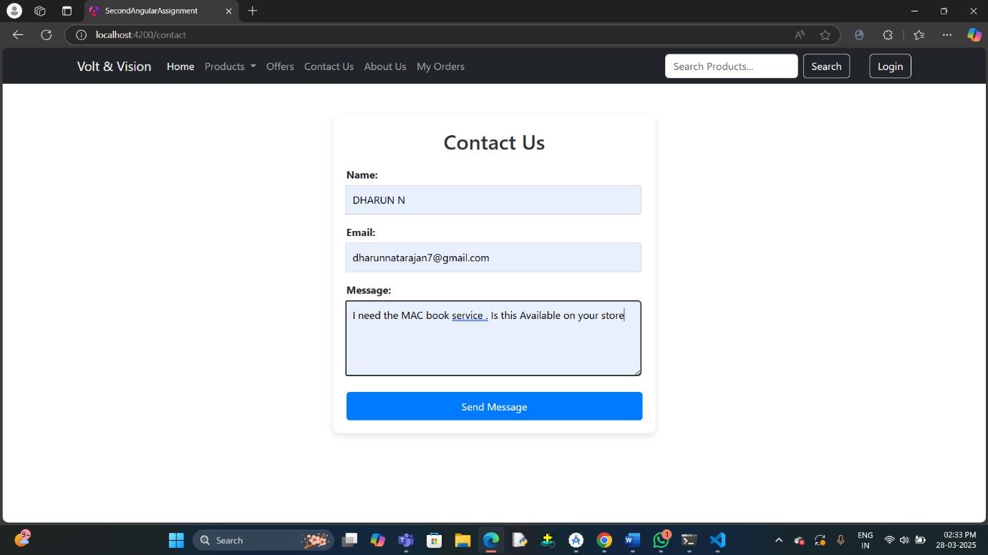

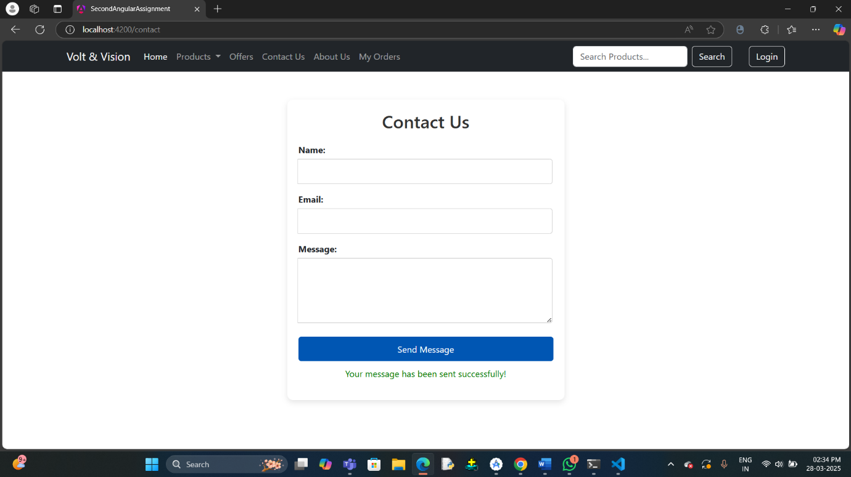

9. ABOUT US PAGE

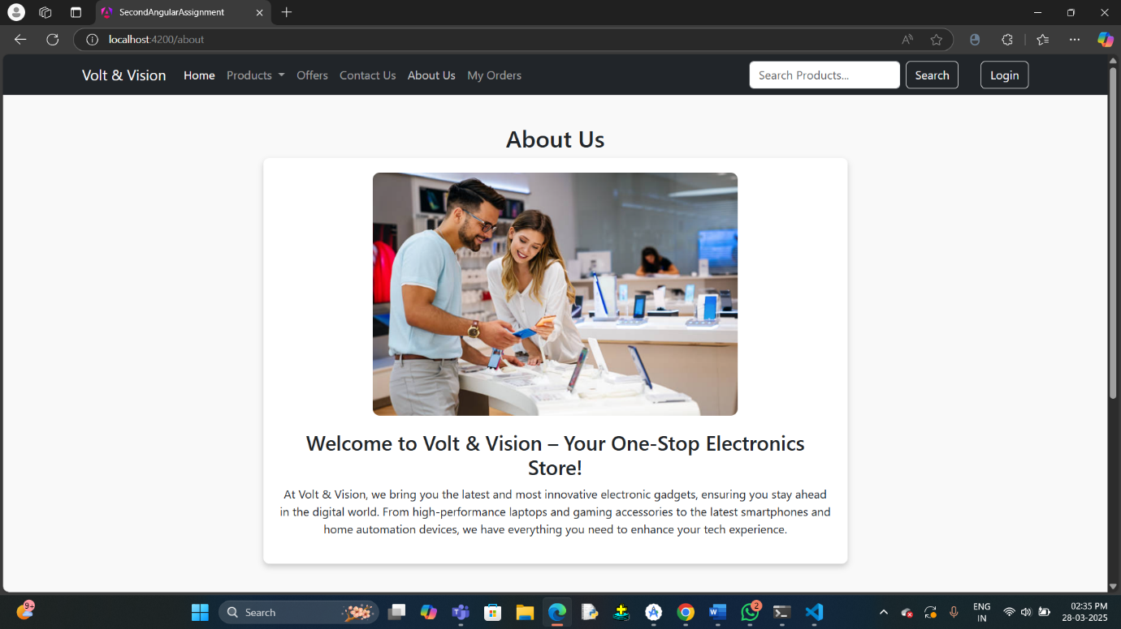

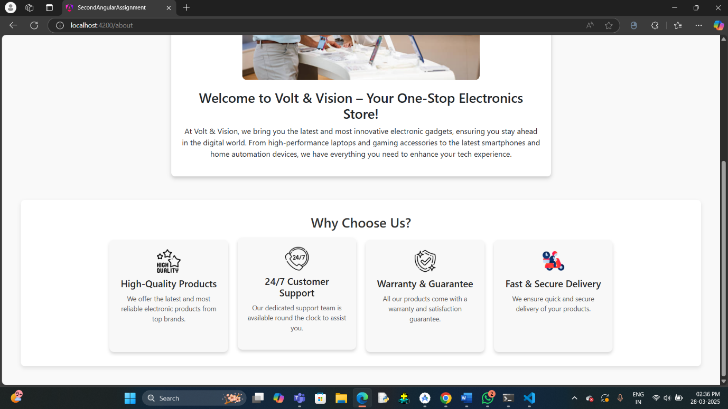

10.MY ORDERS PAGE (BEFORE LOGIN)

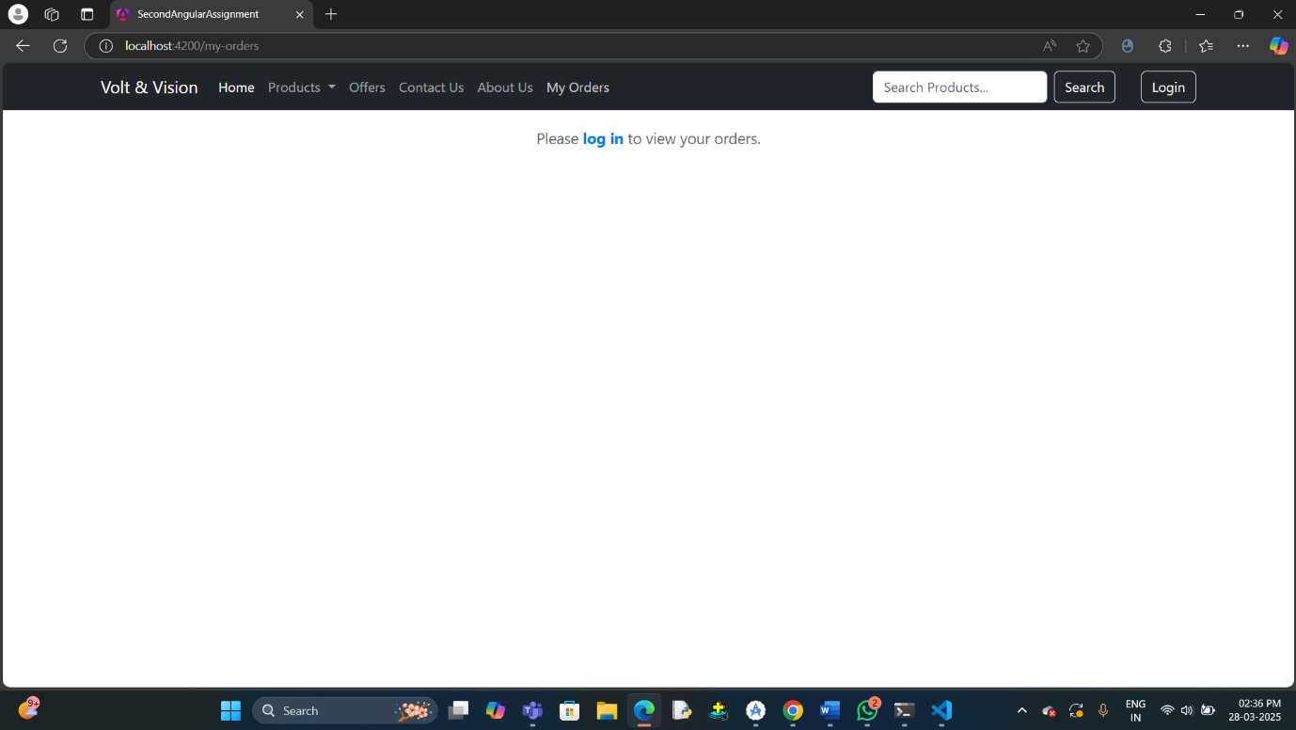

11.SEARCH BAR

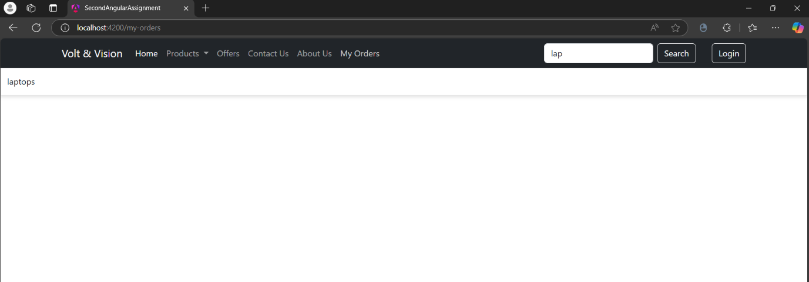

12.LOGIN FORM

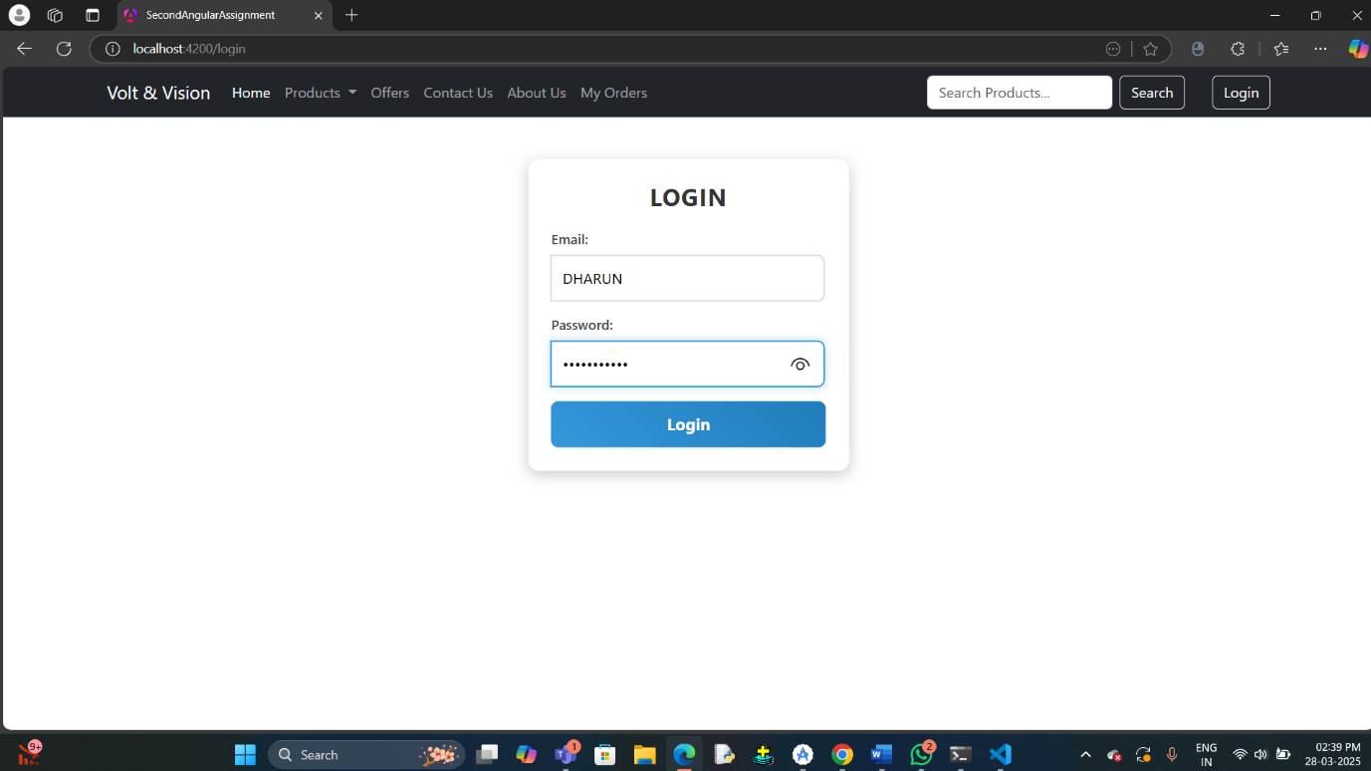

13.HOME PAGE AFTER LOGIN

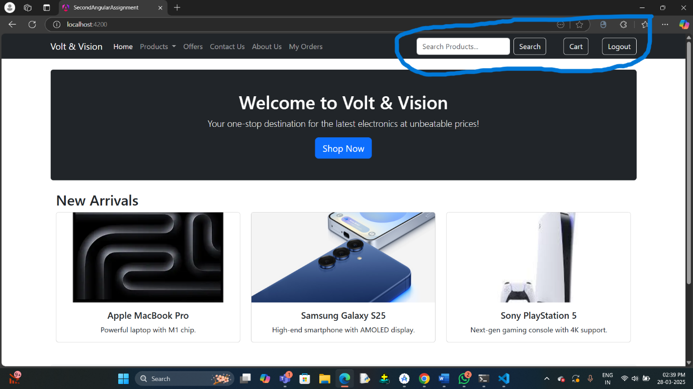

14.CART PAGE (BFORE ADDING ITEMS)

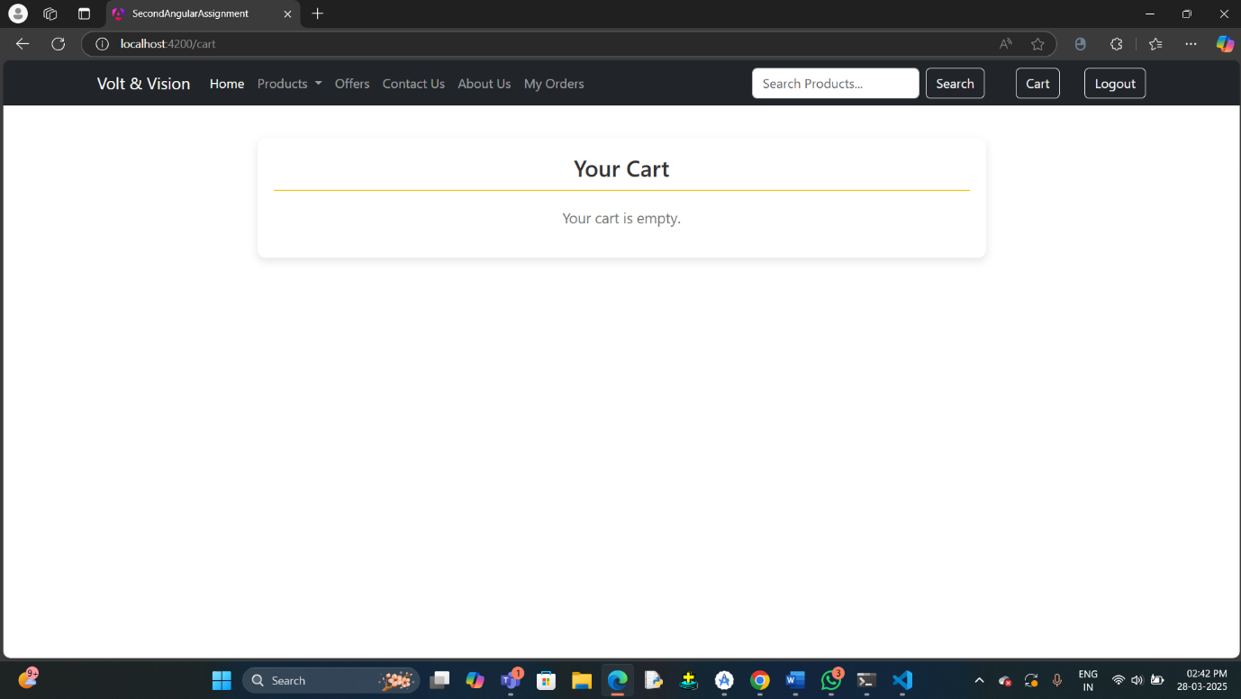

15.ADD TO CART FUNCTIONALITY

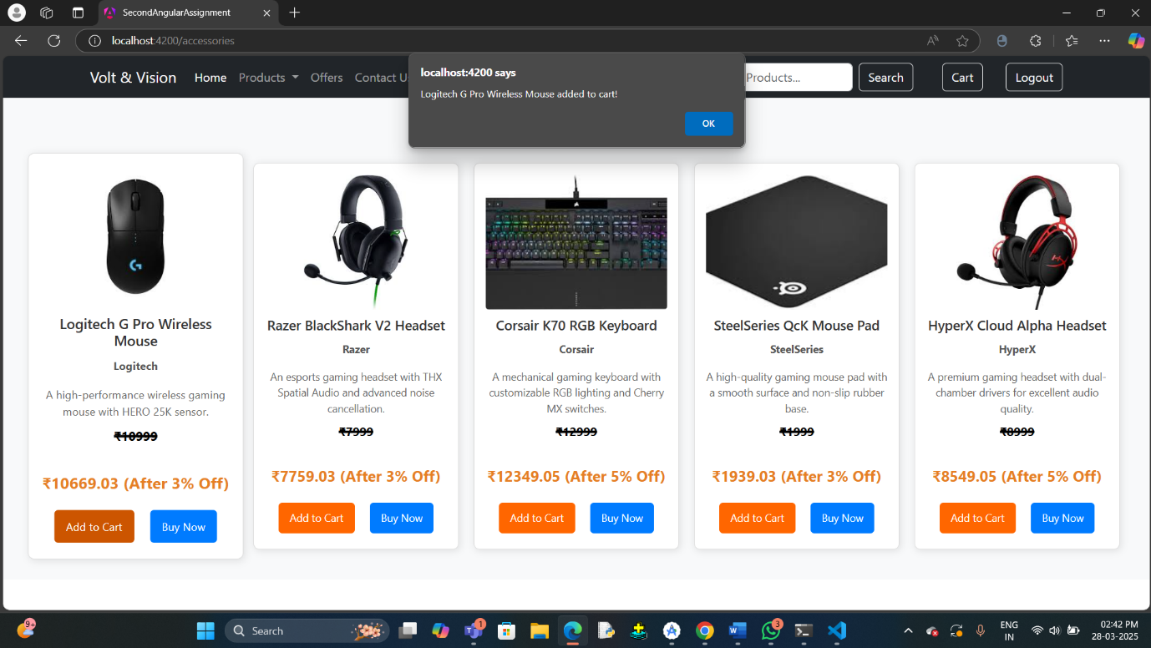

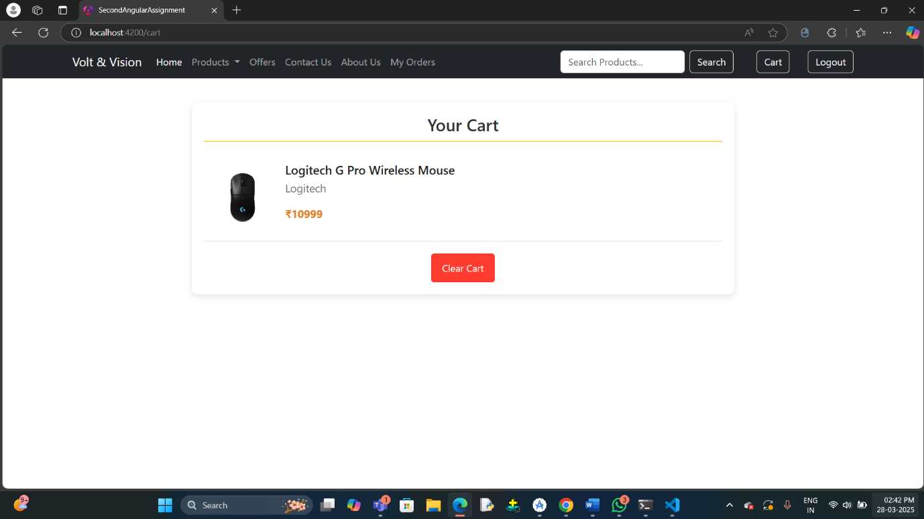

16.MY ORDERS PAGE(BEFORE PLACING ORDERS AFTER LOGGED IN)

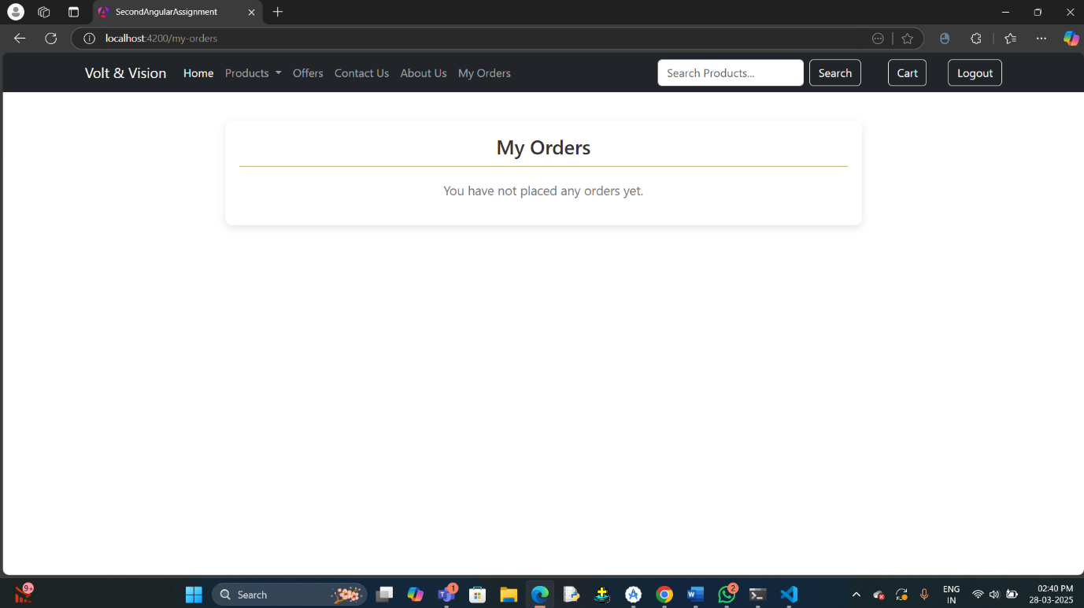

17.BUY NOW FUNCTIONALITY

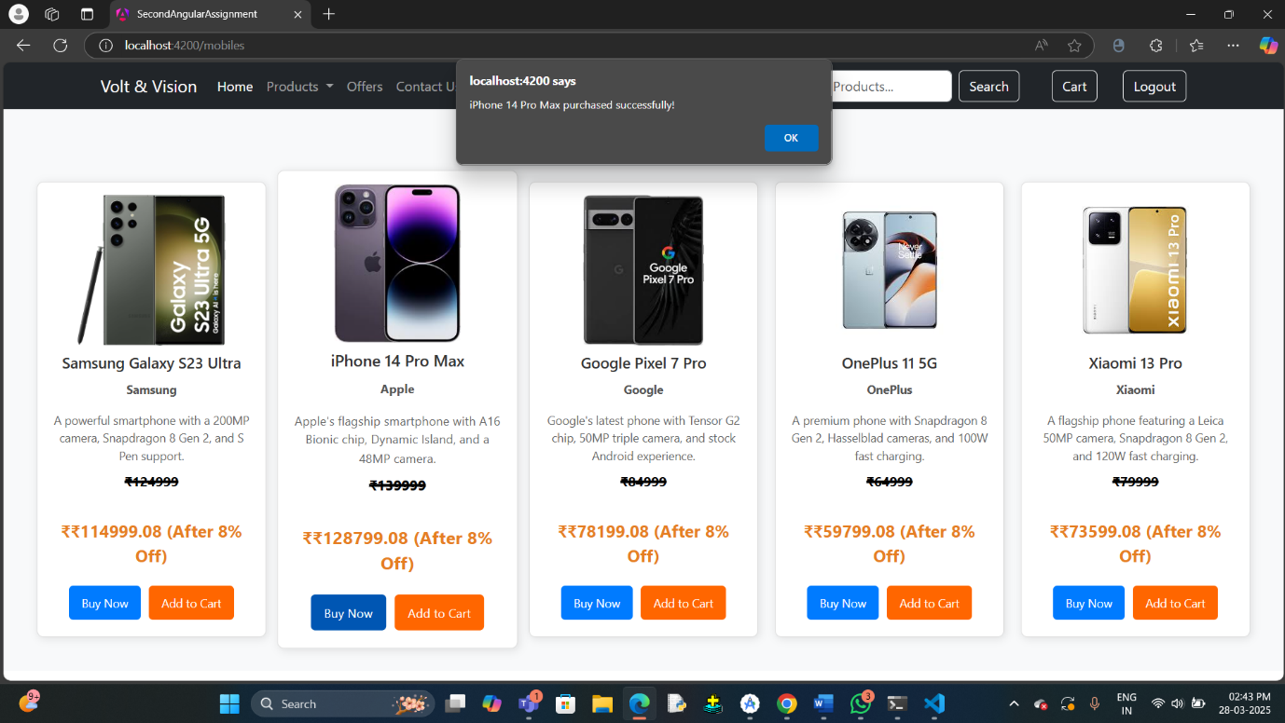

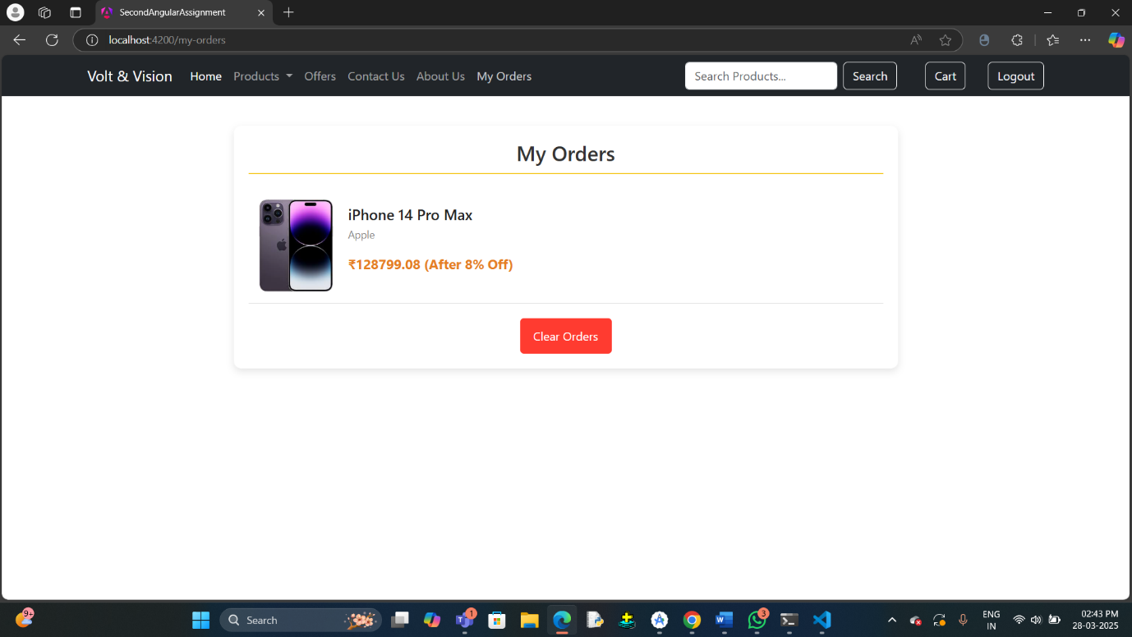

18.LOG OUT FUNCTIONALITY(HOME PAGE AFTER LOGGED OUT)

